SUPPLEMENTARY TABLES and FIGURES

STable 1. Protocol-recommended anticoagulation/antithrombotic regimen

Surgery | TAVR
Pre valve implant procedure
Aspirin 81-100 mg QD Aspirin 81-100 mg QD
- Patients with BMS within one • Patients with BMS within one month or month or drug eluting stent DES within 12 months should be continued (DES) within 12 months should on Clopidogrel/prasugrel prior to their
be continued on implant procedure
Clopidogrel/prasugrel prior to • Patients in atrial fibrillation on warfarin should their implant procedure be bridged with LMW or UF heparin prior to
- Patients in atrial fibrillation on the implant procedure
warfarin should be bridged • Patients with persistent or paroxysmal atrial with LMW or UF heparin fibrillation, not on anticoagulation, will not be prior to the implant required to have a TEE to rule out LA
procedure thrombus prior to implant procedure. If intra-
- Patients with persistent or procedural TEE during TAVR reveals paroxysmal atrial fibrillation, not thrombus, implant procedure will be aborted on anticoagulation, will not be and delayed until patient has been on required to have a TEE to rule warfarin or dabigatran for 30 days. Note: out LA thrombus prior to the thrombus must be eliminated in order to implant procedure. If intra- proceed with TAVR.
procedural TEE during AVR • In patients undergoing concomitant reveals thrombus, implant TAVR/PCI, clopidogrel loading with procedure will be aborted and either 300mg or 600mg prior to the delayed until patient has been implant procedure is recommended in on warfarin or dabigatran for 30 addition to ASA
days. In patients in the surgical group with LA clot seen on intraoperative TEE, implant procedure can proceed per surgical standard of care
Intraprocedural
Heparin will be given to Heparin will be given to achieve/ maintain achieve/ maintain ACT>250 ACT>250 sec.

STable 1 (continued)
Surgery TAVR
Post valve implant procedure
Category I for Stroke Risk  No atrial fibrillation, No recent stents | - ASA 81mg qd  - Clopidogrel 75qd started 24 hours post-surgery for at least one month if clinically safe and at the discretion of the surgical team. In centers that use warfarin post-surgical AVR, Clopidogrel will not be started | - ASA 81mg qd  - Clopidogrel 300mg load within 6 hours of the implant procedure (either pre or post)  - Clopidogrel 75mg qd for at least one month post implant procedure
Category II for Stroke Risk  No atrial fibrillation, recent stents | - ASA 81mg qd  - Clopidogrel should not be discontinued prior to surgery if patient had BMS within one month or DES in 12 months  - Clopidogrel 75qd started 24 hours post-surgery if clinically safe and continued for at least one month post-surgical AVR in those with BMS and a total | - ASA 81mg qd  - Clopidogrel 75mg qd should be continued prior to the implant procedure and after the implant procedure without interruption for at least one month after BMS and 12 months after DES
Category III for Stroke Risk Atrial fibrillation, no recent stents | - ASA 81mg qd  - Patients should be started on warfarin or dabigatran 24 hours post AVR if clinically safe and this should be continued for at least one month or indefinitely if possible. If clinically safe, patient’s being started on warfarin should be bridged with unfractionated or low molecular weight heparin until INR therapeutic.  - If patients are not a candidate for warfarin or dagibatran, Clopidogrel 75mg qd (in addition to ASA 81 mg) can be considered as an alternative | - ASA 81mg qd  - Patients should be started on warfarin or dabigatran 24 hours post TAVR if clinically safe and this should be continued for at least one month or indefinitely if possible. If clinically safe, patients started on warfarin should be bridged with unfractionated or low molecular weight heparin until INR therapeutic.  - If patients are not a candidate for warfarin or dagibatran, Clopidogrel 75mg qd can be considered as an alternative
Category IV for Stroke Risk  Atrial fibrillation, recent stents | - ASA 81mg qd  - Clopidogrel 75mg qd for at least one month post BMS or 12 months post DES  - Patients should be started on warfarin or dabigatran 24 hours post AVR if clinically safe and continued indefinitely. If clinically safe, patients being started on warfarin should be bridged with UF or LMW heparin until INR therapeutic. | - ASA 81mg qd  - Clopidogrel 75mg qd for at least one month post BMS or 12 months post DES  - Patients should be started on warfarin or dabigatran 24 hours post TAVR if clinically safe and continued indefinitely. If clinically safe, patient’s being started on warfarin should be bridged with UF or LMW heparin until INR therapeutic.

STable 2. Baseline Patient Characteristics
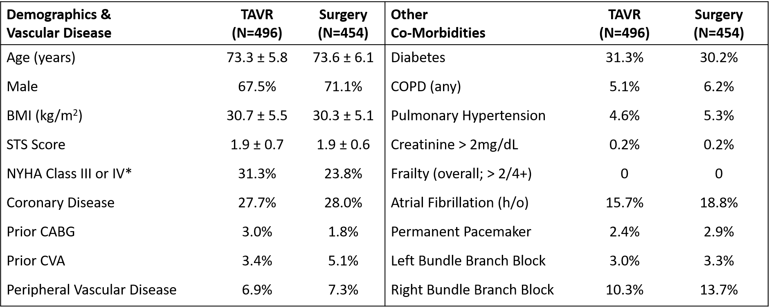
% or mean ± SD; *P = 0.01

STable 3. Primary Endpoint Sensitivity Analyses

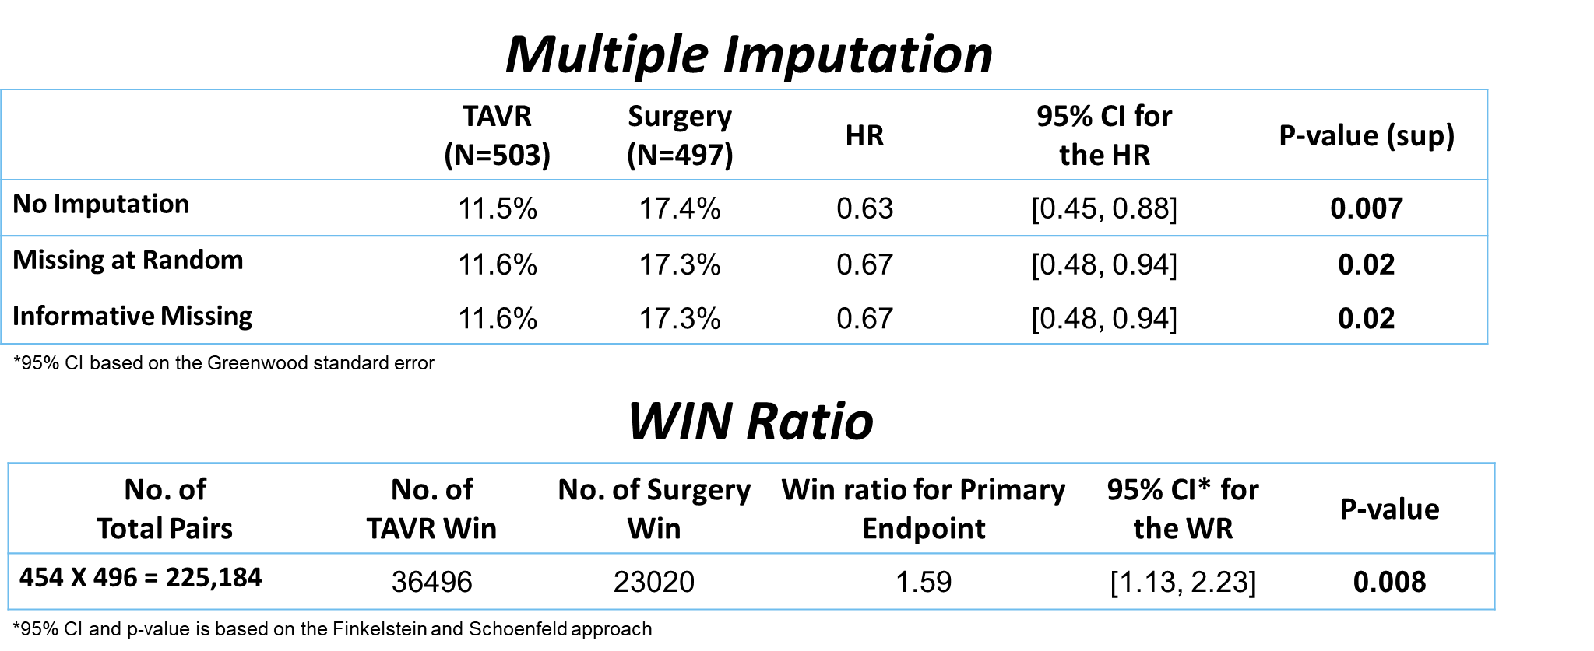

STable 4. Primary Endpoint Restricted Mean Survival Times Through 2 Years
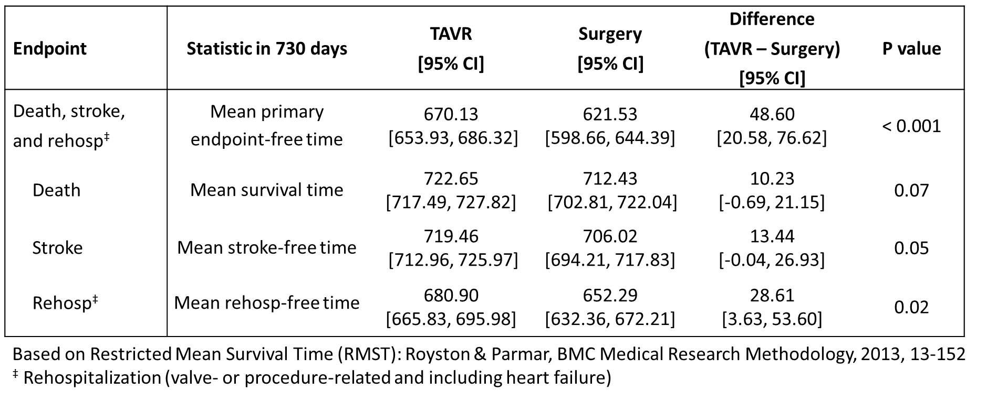

STable 5. Causes of Death from 1 to 2 Years

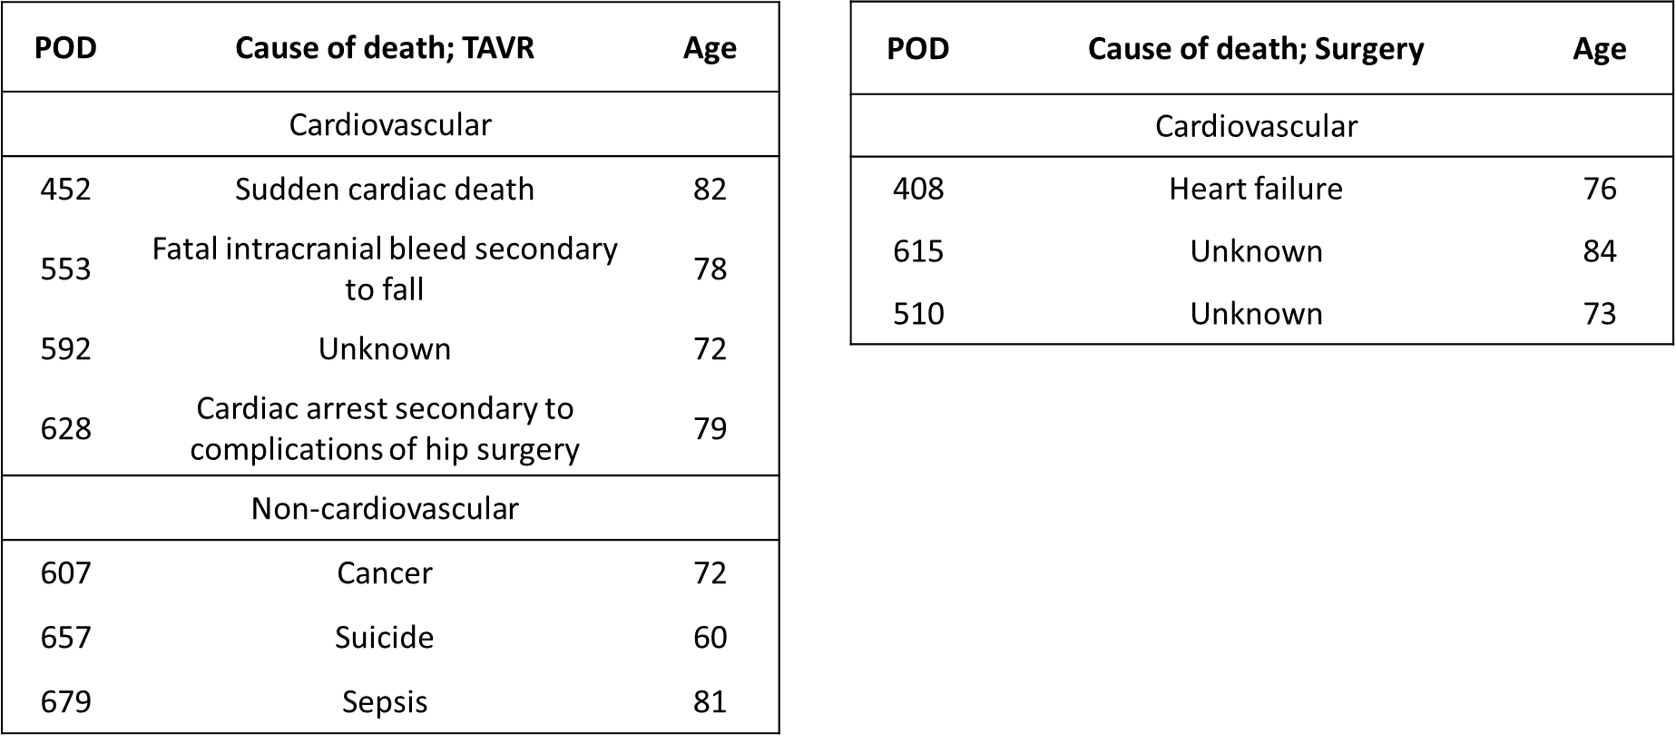

STable 6. Stroke Details from 1 to 2 Years
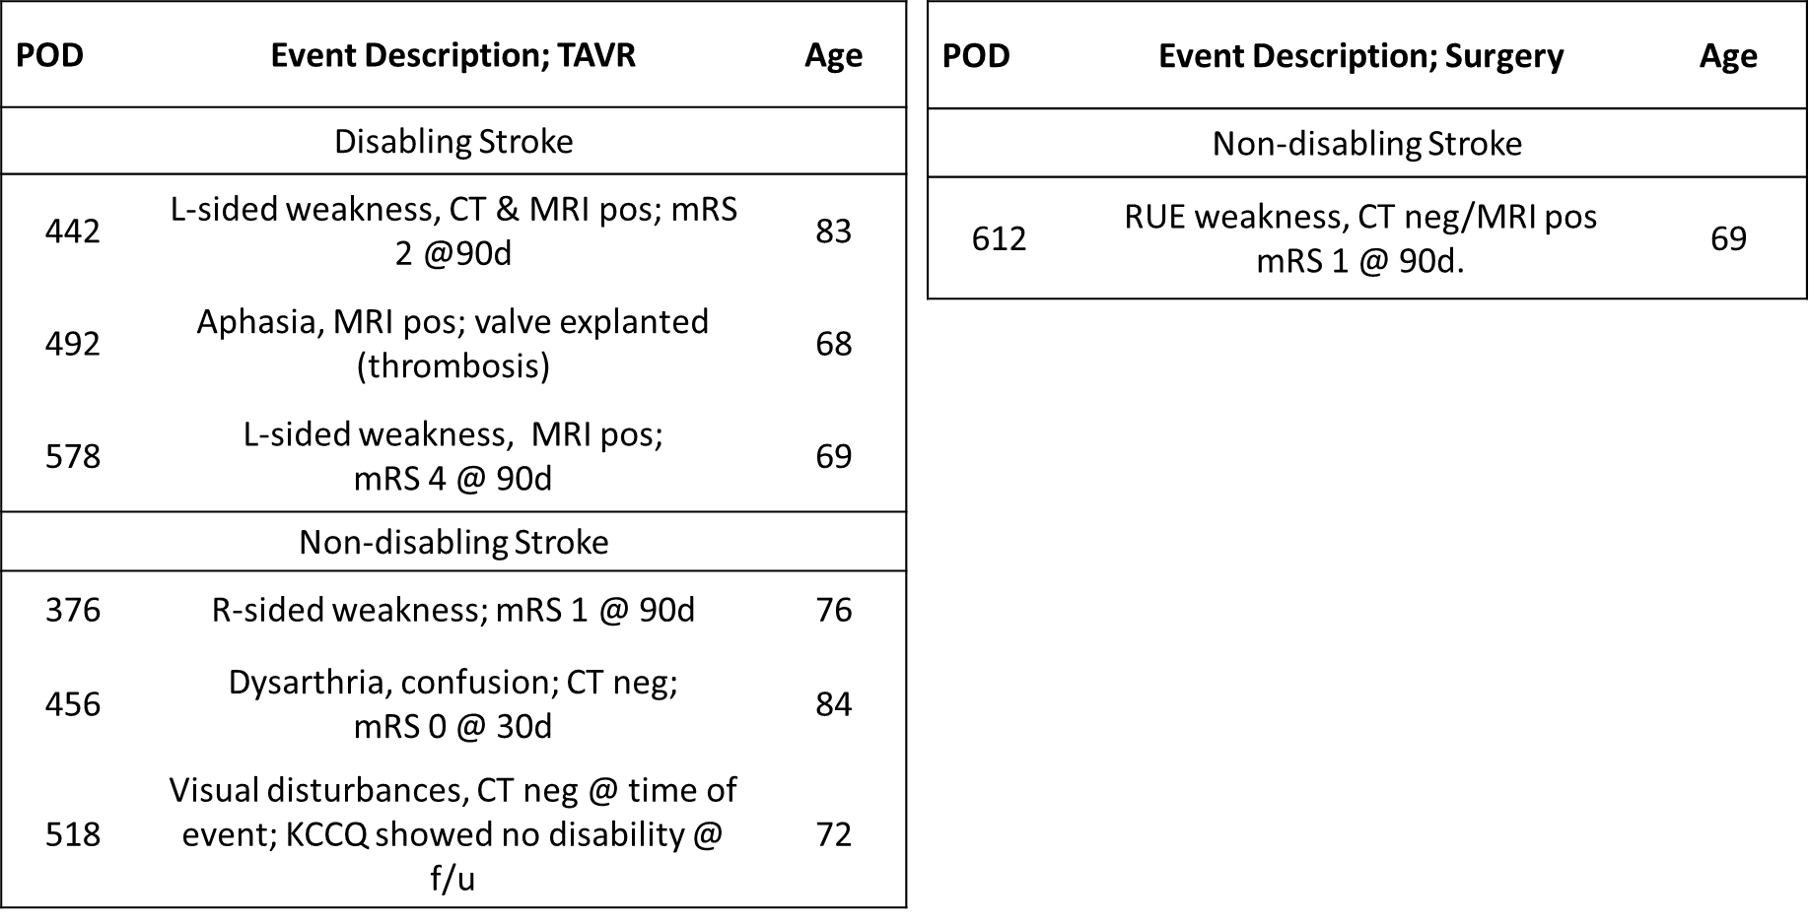

STable 7. Causes of Re-hospitalizations from 1 to 2 Years
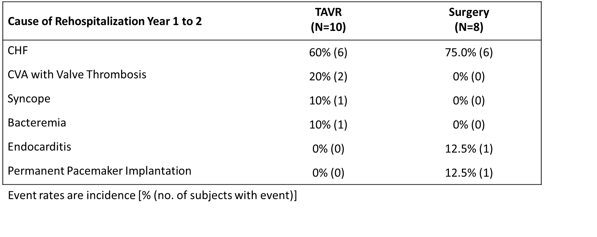

STable 8. Valve Thrombosis Clinical Events Through 2 Years
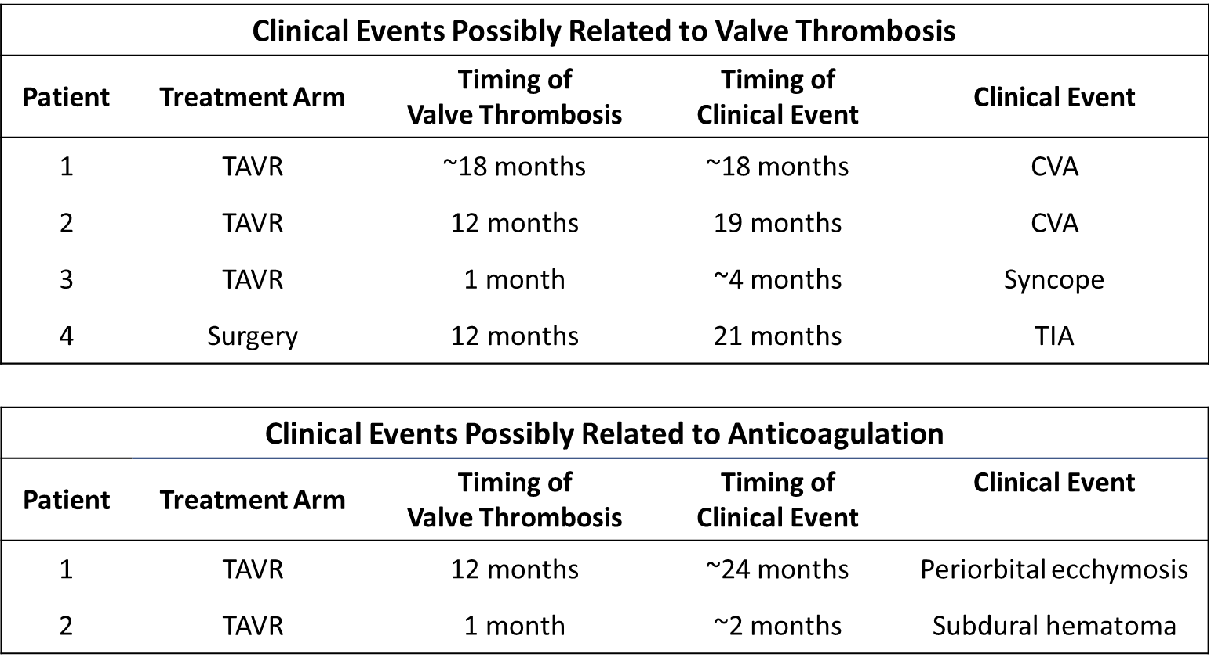

STable 9. Echocardiography Findings Through 2 Years

 | 30-Day Echo |  |  | 1-Year Echo |  |  | 2-Year Echo
Endpoint | TAVR  (N=495) | Surgery (N=453) | P value* | TAVR  (N=495) | Surgery (N=453) | P value* | TAVR  (N=495) | Surgery (N=453) | P value*
Mean gradient (mmHg) | 12.8 ± 4.34  (490) | 11.2 ± 4.30  (426) | 0.42 | 13.7 ± 5.57  (473) | 11.6 ± 4.97  (391) | 0.03 | 13.6 ± 5.53  (431) | 11.8 ± 4.82  (355) | 0.06
Peak gradient (mmHg) | 23.8 ± 7.96  (490) | 21.0 ± 7.95  (426) | 0.36 | 25.0 ± 10.03  (474) | 21.3 ± 8.76  (391) | <0.01 | 25.1 ± 9.95  (431) | 21.8 ± 8.48  (355) | 0.02
Effective orifice area (cm2) | 1.7 ± 0.35  (470) | 1.8 ± 0.41  (395) | 0.87 | 1.7 ± 0.36  (450) | 1.8 ± 0.42  (371) | 0.36 | 1.7 ± 0.37  (410) | 1.7 ± 0.42  (339) | 0.34
LV ejection fraction (%) | 65.7 ± 8.20  (479) | 65.5 ± 8.93  (408) | 0.20 | 66.3 ± 7.95  (453) | 66.5 ± 7.75  (366) | 0.36 | 65.2 ± 7.41  (406) | 65.7 ± 7.61  (341) | 0.61
* p-values are based on a linear mixed model, with value at visit as response, value at baseline and visit number as covariates, treatment (TAVR vs SAVR) and interaction of visit and treatment as factors. Data presented are mean ± SD (n).

SFigure 1. Primary Endpoint Subgroup Analysis Through 2 Years
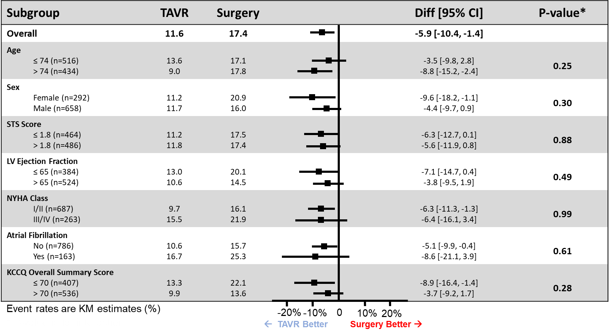
SFigure 2. New York Heart Association Functional Class III or IV Through 2 Years
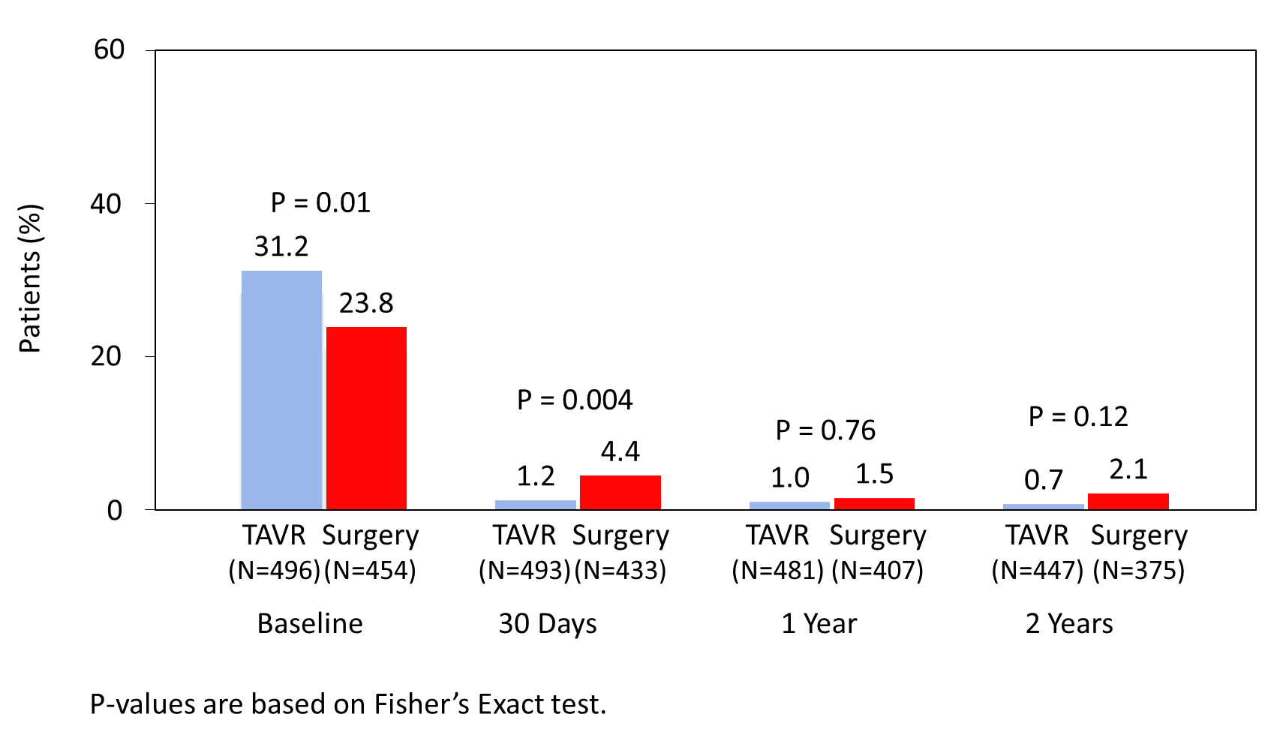

SFigure 3. KCCQ Overall Summary Scores Through 2 Years
